**What is Data Mart?**

* Targets specific functional areas or departments, providing a simplified, targeted data view.
* Data is structured, transformed, and optimized for efficient querying and analysis.
* Smaller in scale, organized around specific subjects, and tailored for the reporting and analytical needs of specific users.

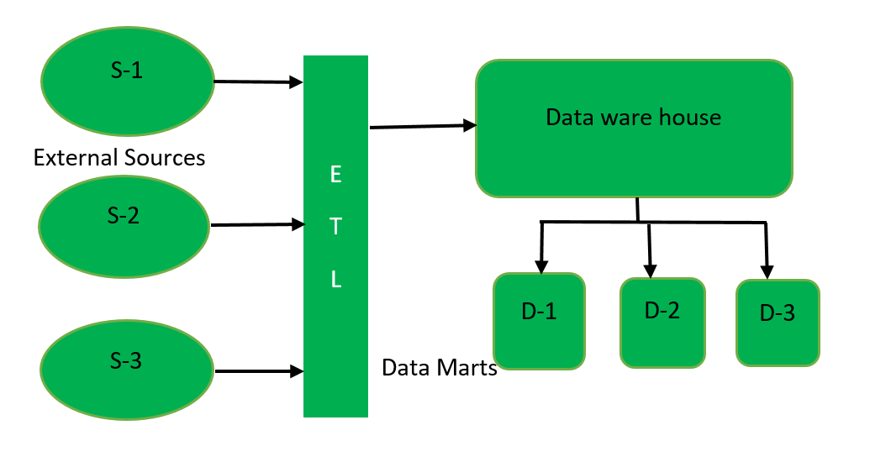

**Types of Data Mart :**

**Independent Data Mart:**

* Independent Data Mart is created directly from external sources instead of data warehouse.
* First data mart is created by extracting data from external sources and then dataware house is created from the data present in data mart.
* Independent data mart is designed in bottom-up approach of dataware house architecture.
* This model of data mart is used by small organizations and is cost effective comparatively.

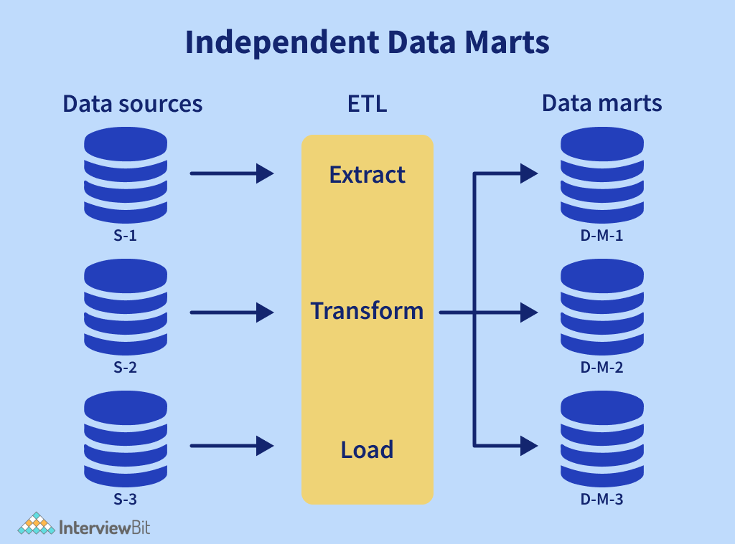

**Dependent Data Mart:**

* Dependent Data Mart is created by extracting the data from central repository, Datawarehouse.
* First data warehouse is created by extracting data (through ETL tool) from external sources and then data mart is created from data warehouse.
* Dependent data mart is created in top-down approach of dataware house architecture. This model of data mart is used by big organizations.

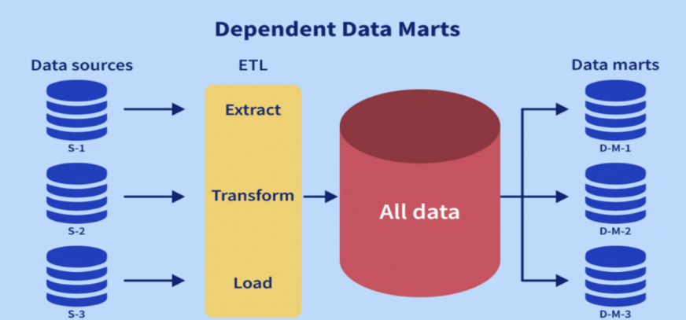

**Hybrid Data Mart:**

* A hybrid data mart combines both independent and dependent data mart components.
* 1Path reflects accessing data directly from external sources and 2Path reflects dependent data model of data mart.

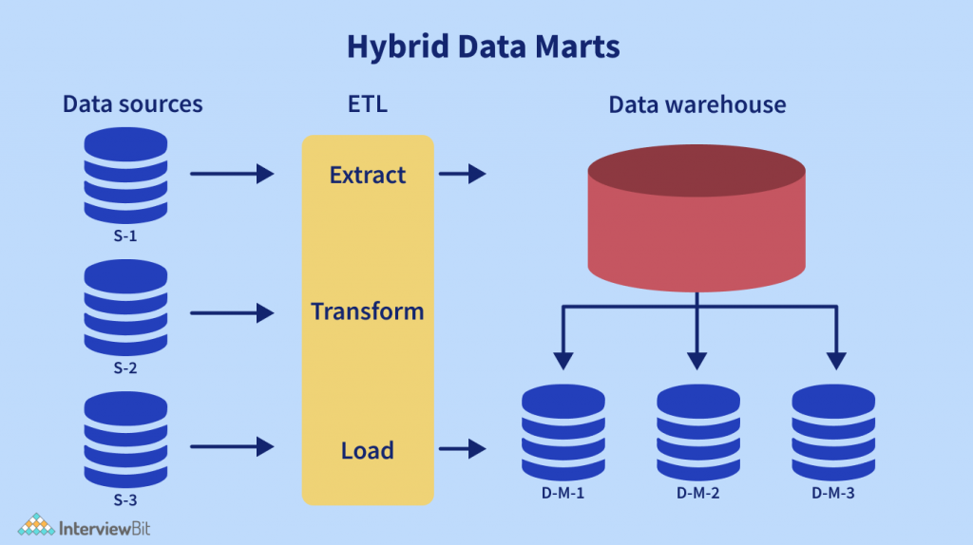

**Structures of Data Mart:**

**Star Architecture in Data Marts:**

* Star architecture is a common data mart structure. It comprises multiple dimension tables surrounding a fact table.
* Primary-key and foreign-key are used to connect the fact table and dimension tables.
* This format supports quick data slice and dice operation for analysis.

**Snowflake Model:**

* A dimensional model extension that offers more normalized data structures is the snowflake model.
* Divides dimension tables into linked tables.
* Helps decrease data redundancy in complex hierarchies.

**Designing of Data Mart:**  
Designing is the first step in implementing data mart. Since, data mart stores data related to a particular topic, so this step includes identification of a subject or a topic related to which data mart will store data. Also it includes the sources to gather the information related to the subject and then designing logical and physical structures of data mart.

**Steps To Follow:**

* Identification of subject.
* Source to gather the information.
* Designing the logical and physical structures.

#### **Application:**

* **Targeted Reporting and Analytics**
* **Sales and Marketing Analytics**
* **Financial Reporting**
* **Customer Insights**
* **Supply Chain and Inventory Management**

#### **Advantages:**

* **Faster Access to Relevant Data**
* **Improved Performance**
* **Cost-Effective**
* **Flexibility and Agility**

#### **Disadvantages:**

* **Data Redundancy**
* **Data Inconsistency**.
* **Limited Scope.**
* **Maintenance Overhead**